Book Country

Software Requirements Document

Version: 1.2

Prepared by
Maria Romanova

Contents
1. Preface 4
1.1. Modification History 4
1.2. Intended Audience 4
2. Introduction 4
2.1. Purpose of the requirements document 4
2.2. Scope of the product 5
2.3. Reference 5
3. Glossary 6
4. User Requirement Definition 7
4.1. User Personas (Actors) 7
4.2. Use Cases 8
5. System Requirements Specification 9
5.1. Functional Requirements 9
5.2. Non-Functional Requirements 11
6. System Architecture 12
7. System Models 13
7.1. Use Case Diagram 13
7.2. Sequence diagram 14
7.3. Class diagrams 17
8. System Evolution 18

Table of Figures

Figure 1 Use Case Diagram 13
Figure 2 Login Sequence Diagram 14
Figure 3 Registration Sequence Diagram 15
Figure 4 Add New Book Sequence Diagram 16
Figure 5 Class Diagram 17

Preface
This should define the expected readership of the document and describe its version history, including a rationale for the creation of a new version and a summary of the changes.

Modification History

Date | Version | Author | Summary of changes
2017-04-18 | V1.0 | Maria Romanova | Started document
2017-04-22 | V1.1 | Maria Romanova
2017-05-23 | V1.2 | Maria Romanova

Intended Audience
This document is intended for any individual user, developer, tester, project manager or documentation writer that needs to understand the basic system architecture and its specifications. Here are the potential uses for each one of the reader types:
Developer: The developer who wants to read, change, modify or add new requirements into the existing program, must firstly consult this document and update the requirements with appropriate manner so as to not destroy the actual meaning of them and pass the information correctly to the next phases of the development process.
User: The user of this program reviews the diagrams and the specifications presented in this document and determines if the software has all the suitable requirements and if the software developer has implemented all of them.
Tester: The tester needs this document to validate that the initial requirements of this programs actually corresponds to the executable program correctly.

Introduction
The main objective of this project is to design web-based application for book library. The purpose the project is to provide a friendly environment to maintain the details of the book catalog, library member accounts, loan history, and provide a convenient online book reservation service.

Purpose of the requirements document
The main objective of this document is to illustrate the requirements of the project Book Country (web library catalog and book reservation system). The document gives the detailed description of the both functional and non-functional requirements proposed by the client. This document describes the hardware and software interface requirements using various diagrams (E-R, UML), definitions and figures.

Scope of the product
The Book Country is basically updating the physical library catalog system into a web-based application so that the users can know the details of their accounts, availability of the books and maximum limit for borrowing.
The project is specifically designed for librarians and library users. The product can be used by any existing or new library to provide an access to library catalog and reservation service through the internet.
The project can be easily implemented under various situations. The new features can be added as and when its required, making the reusability possible as there is flexibility in all the modules.

Reference

Print References
- Tsui, Frank F., and Orlando Karam. Essentials of software engineering. 2nd ed. Sudbury, Mass: Jones and Bartlett Publishers, 2011.
- Freeman, Adam. Pro Asp.net Core MVC. 6th ed. Berkeley, CA: Apress, 2016.
- Freeman, Adam. The definitive guide to HTML5. Berkeley, CA New York: Apress Distributed to the Book trade by Springer, 2011.
- Fowler, Martin. Patterns of enterprise application architecture. Boston: Addison-Wesley, 2003.

Electronic References
- Dewey Decimal Classification System. http://bpeck.com/references/DDC/ddc.htm
- MySQL Database. https://www.mysql.com
- Microsoft Visual Studio. https://www.visualstudio.com
- Dapper ORM. https://github.com/StackExchange/Dapper
- Mockaroo. Realistic data generator. https://www.mockaroo.com
- Font Awesome. The iconic font and CSS toolkit. http://fontawesome.io
- Bootstrap. The HTML, CSS, and JS framework for responsive design. http://getbootstrap.com
- Eeles, Peter. Capturing Architectural Requirements. https://www.ibm.com/developerworks/rational/library/4706.html. Nov. 15, 2005 [Apr. 23, 2017]

Glossary

Term | Meaning
Book Country | Web Application for book library online catalog and reservation system.
Users | These are users who interact with the system directly. For instance, librarians, borrowers, any unregistered person
Borrowers | Any library user who registered in the Book Country.
Librarian | A user who have rights to add, delete, modify new books, and view loan history of all borrowers.
Visitor | A person who does not have an account in the Book Country.
ISBN | International Standard Book Number.
Dewey Code | Book Number in Dewey Decimal Classification System
DB | An abbreviation for Database.
MySQL | An open-source relational database management system (RDBMS).
ORM | Object-relational mapping. A programming technique for converting data between incompatible type systems in object-oriented programming languages. This creates, in effect, a "virtual object database" that can be used from within the programming language.
MVC | Model–view–controller. A software architectural pattern for implementing user interfaces on computers. It divides a given application into three interconnected parts in order to separate internal representations of information from the ways that information is presented to and accepted from the user. The MVC design pattern decouples these major components allowing for efficient code reuse and parallel development.
.NET | A set of software technologies from Microsoft for connection information, people, and computer systems.
SRD | An abbreviation for Software Requirements Document. This is the document you are reading.
User Persona | A persona is the profile of a fictional user that represents the intended audience(s) for this product. A persona should share characteristics with real people, but should not directly describe any real person.
System | Book Country web application alias.

User Requirement Definition
The purpose of this section is to provide the high-level requirements from client’s perspective.

User Personas (Actors)
Borrower: Borrower is a Library user who has a registered account in the Book Country system and can log in under her credentials (email as login and password created at registration) and make various actions:
- browse catalog
- view book details
- view her account details
- make a request for issue/renew/return book.

Librarian: Librarian is a Library personnel who has the administrative rights in the Book Country system and have access to do the following:
- add new book
- update records regarding to a book details
  - title
  - author
  - ISBN
  - Dewey code
  - edition
  - number of book pages
  - price
  - language
  - binding format
  - publisher
  - date published
  - quantity
  - book cover image
- update records regarding book loans
  - issue date
  - actual date when the book was returned

Visitor: Visitor is an unregistered person (does not have an account in the System) who can visit the Book Country website, browse the book catalog, view library contact information, and who can choose to register an account by signing up.

Use Cases

Borrower Registration
Brief Description: This use case allows a borrower to register an account in the Book Country website, providing necessary personal and contact information such as: email (used as login), password, full name, date of birth, full mailing address (US only), contact phone number.

Login
Brief Description: This use case describes how a user logs into the Book Country System. The actors starting this use case are Borrower and Librarian.

Browsing Catalog
Brief Description: This use case allows a user to select the book(s) from the book catalog narrowing the results with various filters: by title, author, ISBN, genre, language. The actors starting this use case are Borrower, Librarian and Visitor.

Book Reservation
Brief Description: This use case describes how the logged in the System user can make a book reservation online in a Book Country website in order to later visit physical library and pick up the reserved book. The actor starting this use case is Borrower.

Cancel a Book Reservation
Brief Description: This use case describes how the logged in the System user can cancel his/her book reservation online in a Book Country website. The actor starting this use case is Borrower.

Issue a Book
Brief Description: This use case allows a user to issue a book that was reserved. The actor starting this use case is Librarian.

Return a Book
Brief Description: This use case describes how the book return date is entered updating the loan record when the physical book is returned into the library. The actors starting this use case are Borrower and Librarian.

Renew a Book
Brief Description: This use case describes the process of renewing a book, which is basically is reduced to updating the return date for a book. The actors starting this use case are Borrower and Librarian.

Add a Book
Brief Description: This use case allows a user to add new book to the catalog entering the all required data describing a book (title, author(s), edition, publisher, ISBN, Dewey code, language, publishing date, quantity, number of pages). The actor starting this use case is Librarian.

System Requirements Specification

Functional Requirements

Borrower Registration
The person who wish to use Book Country should choose a menu option (or button) in a System website named “Register” or “Sign Up”. Then the System shall provide a user registration form with the following information:
- email address (will be used as login)
- first name
- last name
- date of birth
- full mailing address
    - street address
    - secondary address (apt., suite, office number)
    - city
    - state (two letters abbreviation)
    - zip code
  - phone number
After entering all the information, the person shall click a button to submit the registration form and the System shall display a confirmation message that the form was submitted (or error message otherwise).

Login
The System should provide a menu option named “Log In”. After selecting this option, the System shall display a form with two fields (login and password) and two buttons named “Log In” and “Cancel”. The entered credentials should always be verified and the System should display an error message if the credentials check fails (for example, a user account does not exist or login-password pair does not match in the existing record.)

Browsing Catalog
The catalog should be open for searching for any person (either with or without an account in the System) visiting the Book Country website. The catalog should display the book cover images with a title and author(s). By clicking on a book cover image the user can open a new page with a book detailed view: book cover, tittle, author(s), edition, publisher, date published, format, number of pages, language, ISBN, Dewey code, number of copies available.
The catalog should have a searching options/filters in order to narrow the results displaying and find a particular book(s). A book can be found by:
- title
- author
- genre defined by Dewey code
- ISBN (ISBN-10 or ISBN-13)
- language

Book Reservation
This feature should be available for registered borrowers only. To request a book issue the borrower can click a button in the book detailed view page. After this action, the System shall display a message confirming the successful result (for example, “Your request for book XYZ was processed successfully.” or “The book XYZ was added to your list/cart”) or the error message otherwise.

Cancel a Book Reservation
This feature should be available for registered borrowers only. To cancel the request for a book issue the borrower can click a button in the requested book list view page. After this action, the System shall display a message confirming the successful result (for example, “Your reservation for book XYZ was cancelled.”) and a book shall be removed from the reservation list, or the System shall display an error message otherwise.

Issue a Book
This feature is available for librarians only. When the borrower physically visit the library for picking up the reserved books, the librarian should be able find the book loan record in a System, containing the information about this borrower, book, issue date, return date and the blank date for actual return. Then the librarian gives a physical book and updates the record, entering the issue date. The return date shall be calculated as 3 weeks from the issue date and updated automatically.

Return a Book
This feature is available for librarians only. When the borrower physically visit the library for returning a book, the librarian should be able find the book loan record in a System, containing the information about this borrower, book, issue date, return date and the blank date for actual return. Then the librarian takes a physical book and updates the record, entering the actual return date.

Renew a Book
The book loan can be extended by request from a borrower. The System should provide a tool for such request: it can be a menu option in a Book Country website or a button in the borrower account view page.

Add a Book
This feature is available for librarians only. The System should have a menu option for adding new books. When the librarian chooses this menu option, the System shall display a new page of registration form for a new book containing the submit/cancel buttons and the following fields:
- title
- edition
- date of publication
- list of authors
- language
- format
- ISBN
- Dewey code
- price
- quantity
- number of pages
- book cover image file upload
The System should always check for existing author(s)/ISBN and add new ones only when the entered records was not found.

Non-Functional Requirements

Scalability
The initial design is intended for small-sized libraries (fewer 35,000 users). However, the System should be able to adapt for a medium-sized library as well (serving a city or place with a population of 35,000 to 100,000 people) given a possible steady increase in the number of accounts and books over time.

Performance
The maximum response time for any request should not exceed 2.5 seconds for any action. On average, all requests in this application should not surpass more than two quarters of a second.

Security
The System should provide a mechanism for user credentials validation and display an error message when login or password is invalid, without specifying which input exactly is invalid. All the user passwords stored in the database should be encrypted with reliable algorithm.

Interface & Usability
The System should have a user-friendly graphical user interface (GUI). All the menu options, buttons, labels, messages should be in English language.

Web Browser Supportability
The Book Country web application should be able to function in all major browsers: Internet Explorer, Chrome, Safari, Mozilla.

Database
All the information used by Book Country should be stored in a relational database managed by MySQL, an open-source relational database management system (RDBMS).

System Architecture

Key Objects
The key objects of a Book Country system which should be defined in model are the following:
- Book
- Author
- Publisher
- Borrower
- Address
- Loan

System Components
The system should include the components according multilayer system architecture:

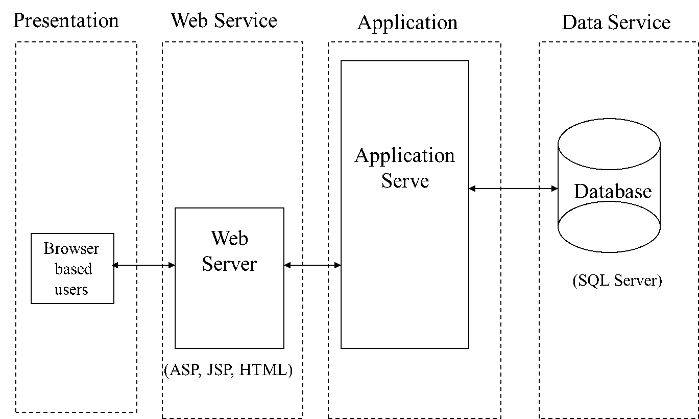

System Models
This section includes UML diagrams showing the relationships between the system components and the system and its environment.

Use Case Diagram

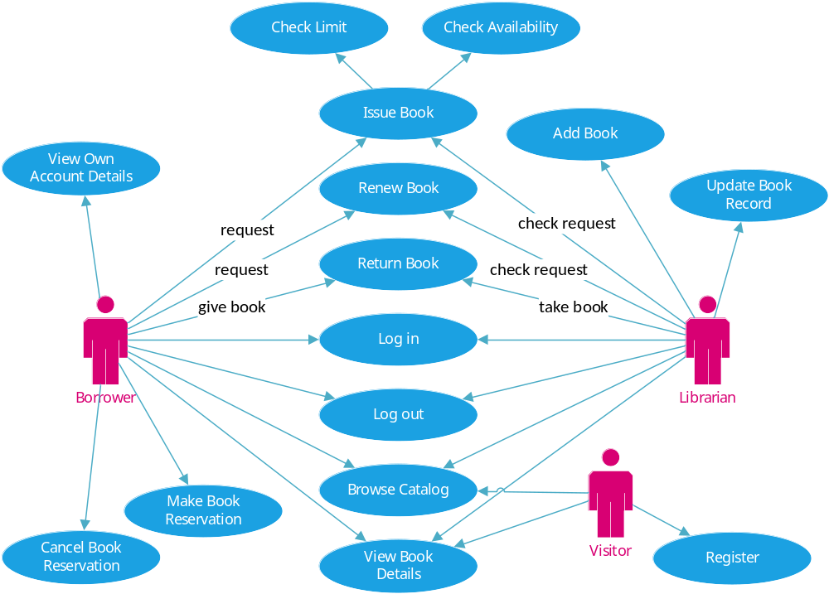
Figure 1 Use Case Diagram

This is a broad level diagram of the project showing a basic overview. The borrowers can be either library users or librarians themselves. This application will provide a search/browse functionality to facilitate the search of resources. The search will be based on various categories, for example, book title, author, ISBN, library book classification code. Further the librarians can add/update the resources. The borrowers can request issue/renew/return of the books for which they would have to follow certain criteria.

Sequence diagram

Login
When user wants to log in, he visits Login page by clicking button Login and enter his/her credentials (email address and password). If entered credentials are valid, then system shows the welcome message and display menu options available for registered users: My Profile, My Reservations.

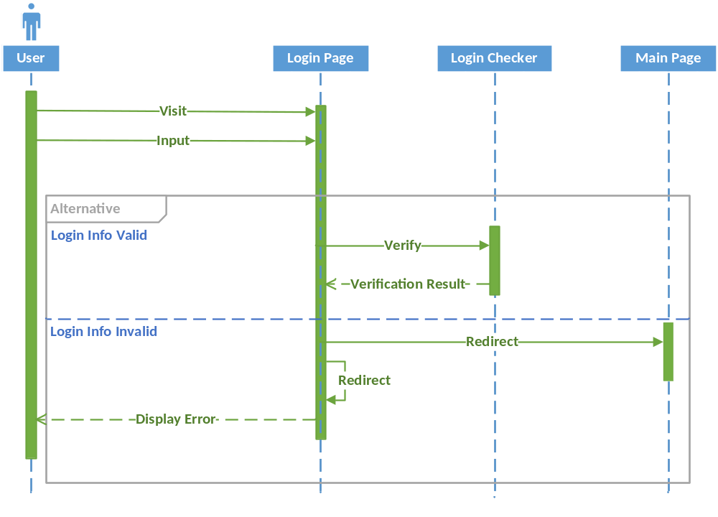
Figure 2 Login Sequence Diagram

Registration
In order to be able make book reservations, any visitor can register in a Book Country website. When visitor wants to register, he clicks menu option Register on the main page and, after redirection to registration page, he/she should enter valid email and password along with password confirmation and click button Register. After that the system adds new user account into database and displays Borrower Profile page, where user can enter his/her personal and contact information.

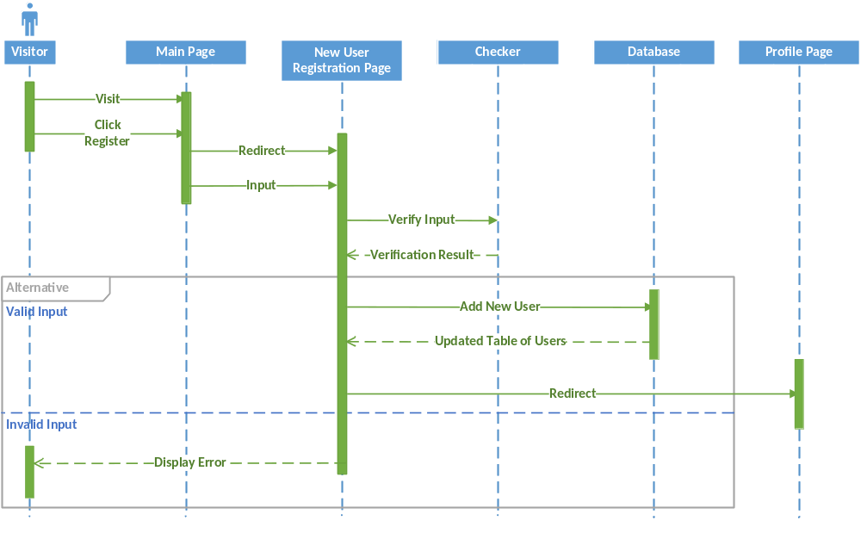
Figure 3 Registration Sequence Diagram

Adding New Book
For adding new book to the catalog the Librarian should click menu option New Book, then the System displays a New Book Form page. The Librarian enters all the required data for a new book and clicks button New Book. If all the entered data is valid the System redirects to the Main page where a new book is added at the end of the catalog.

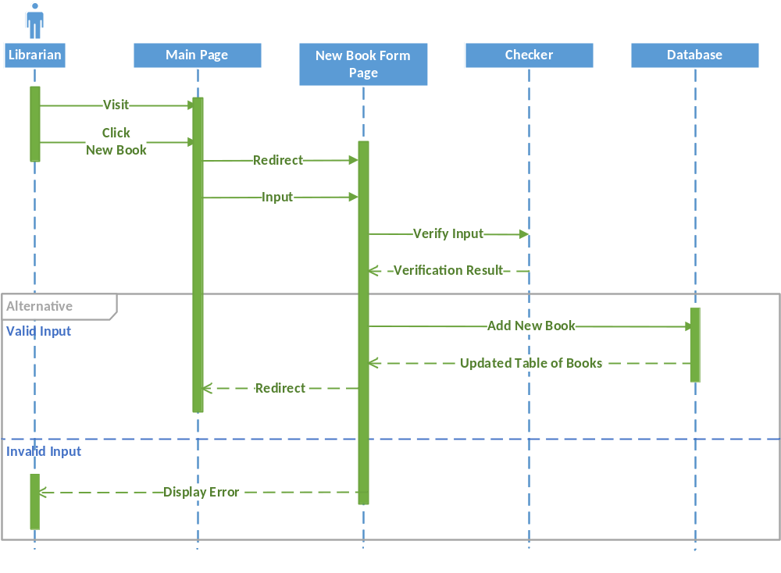
Figure 4 Add New Book Sequence Diagram

Class diagrams

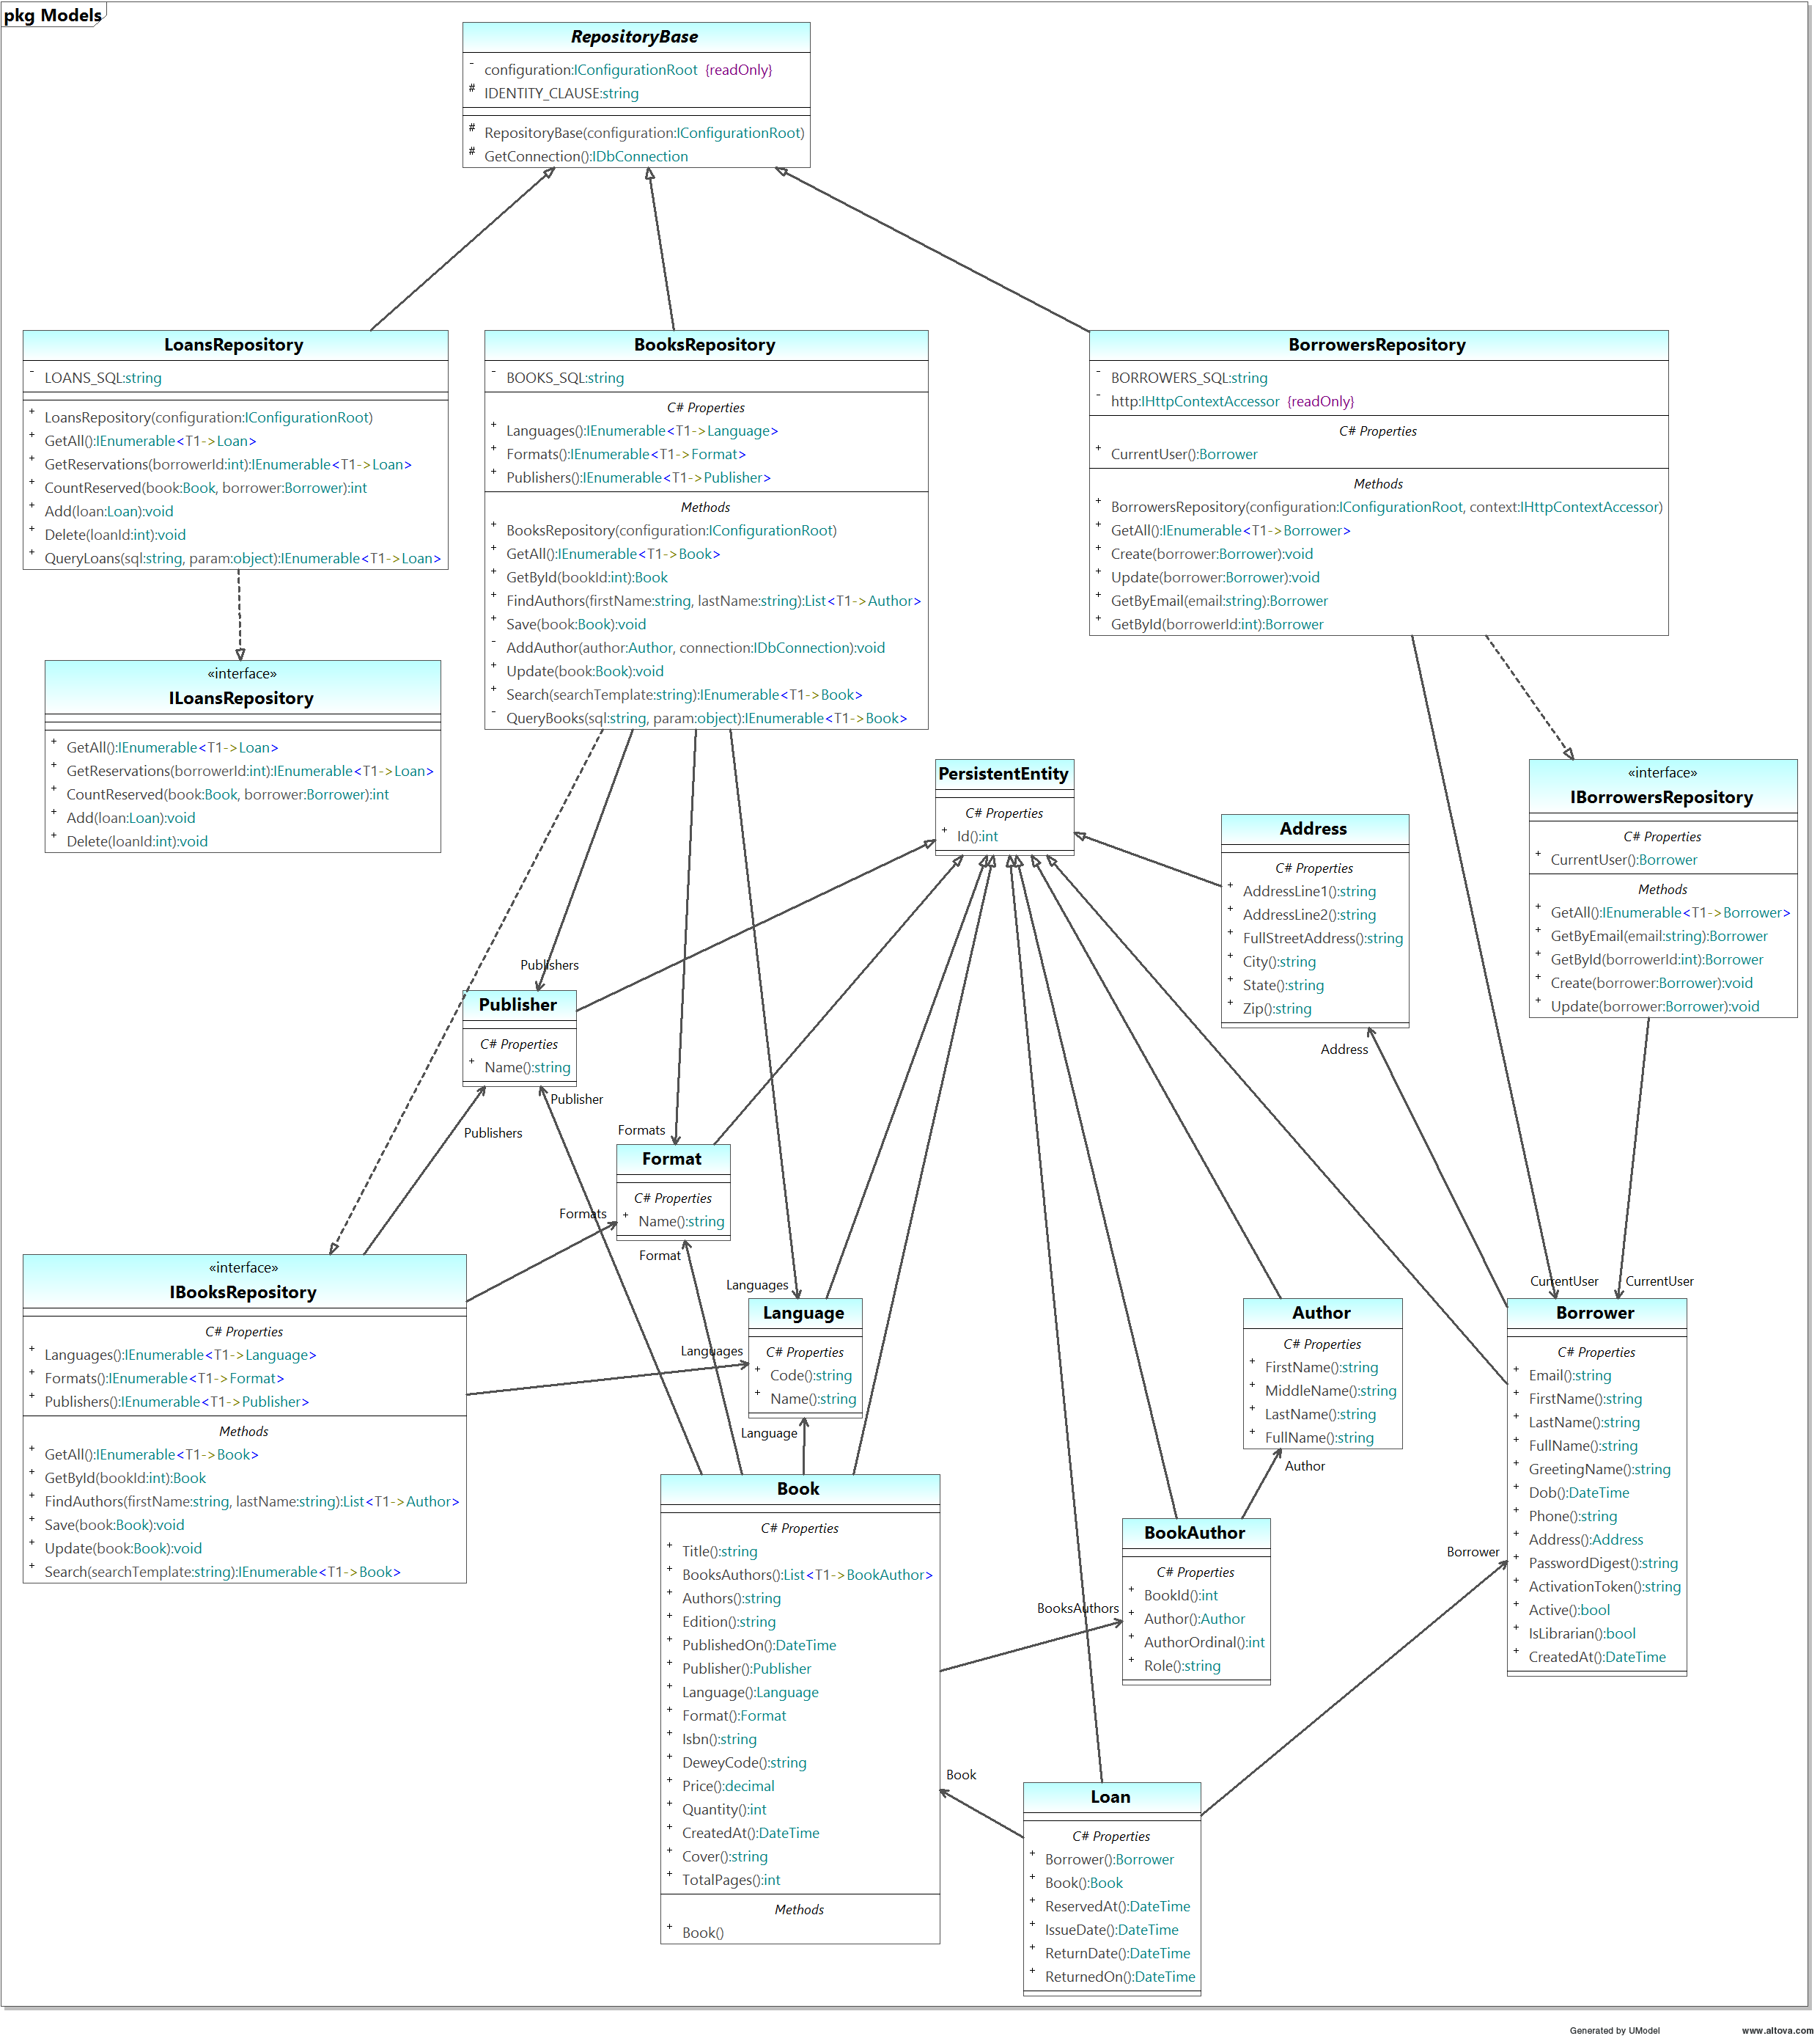
Figure 5 Class Diagram

System Evolution
Despite the fact that Book Country design is initially intended for a small-sized library (fewer 35,000 people), it can be adapted and used by the medium-sized library (serving a city or place with a population of 35,000 to 100,000 people) or even bigger. The increased number of user accounts and books can reduce the time of retrieving information from the database. The Book Country database schema includes table indexes for the key search columns in order to make the search through a large-scale data faster.
Another feature of the Book Country database is a comprehensive list of languages and book formats. The lists include 185 languages and 12 book formats, including, for example, the rare Uyghur language (spoken by 0.12% of world population) and a rare book format, octavo, used mostly in past centuries. The small-sized library catalog probably won’t have such books, but the medium or large library can.
It should also be noted that the architectural model used for design, multi-layer application with MVC pattern, allows the flexibility for the System future modifications.

